Intro:
This modified database was designed for the use in the John King Laboratory, School of Pharmacy Queens University Belfast. Due the participation in the S-Lab awards 2014 a copy of the database file is included together with this manual. As provided free of charge neither the John King Lab nor the creator of the database will be subjected to any responsibility about the use –or misuse- of this software, or any loss or damage incurred by third parties while using it.
Belfast 2nd April 2014

To set up:
This database has been design to work in Windows system with an original copy of Microsoft Office; having been tested with Microsoft Office 2007 and 2010 versions and Windows XP, Vista and 7 versions. It may work in other configurations and/or OS but that has not been tested yet.
Transfer the content of the zip file to any location in your computer. For the database to work properly the folder SOP and the folder db graphics should be in the same folder as the database file.
The database uses macros and vba code to work; hence it is necessary to have them active (check security levels, or a pop-up at the top of the program when opening)
In order to use it in a network, remote access to the main database file and folders mentioned above is necessary. The simplest way is to set a shared folder in the computer working as a server of the system and connect the client computers to it. It may be possible to use systems like Citrix and Samba but again this has not been tested yet.
When using it from a shared folder only one user at a time can have access to the database (this is to avoid problems with duplicate files or corrupt versions), and this is done by having an integrated monitor that after five minutes of inactivity will close the application, any change not saved by the user will NOT be saved when the application closes due inactivity.

Using the application:
From the main menu there is direct access to the main functionalities of the program:
- Chemical List (to access the main functionality; view, add or modify chemical compounds and bottles. The list is searchable by fragments of the name OR CAS number in the records)
- Solvents in Bulk (allow the control of chemicals with high turnover or to manage a separate location for storage of common-use chemicals)
- Equipment List (access the equipment part, allows to view, add or modify equipment and spare parts link to each hardware; change their availability condition and access the SOP folders)
- Search by Location (shows all the chemicals which their main place of storage is the one selected in the dropbox; does not provide access to the detail view, neither modifying or adding new chemicals)
- Admin Menu (is the menu to access less-often use characteristics):
  - Equipment Locations – Names of the possible locations for equipment, what will be shown when adding/modifying equipment as possible locations
  - Chemicals Locations – Names of the possible locations for chemicals, what will be shown when adding/modifying chemicals as possible locations
  - SOP Folders – Name of the folders containing the information about equipment and their related SOP’s. The folder must be created MANUALLY inside the SOP folder in the same location as the main database file. The name of the folder created and the one introduced here HAVE TO BE THE SAME, if not when trying to open the folder from the equipment view it will provide an error message
  - Suppliers –Information about the suppliers of both chemicals and equipment, allows the record of the name of the company, webpage, person of contact (or sales rep.) and contact email. Single click over the webpage address will open it in a web browser.
  - People –For the record of the people in charge of the chemicals and equipment. The name field will be the one displayed when assigning an ownership to a chemical or hardware.

About the chemical list:

As the main feature in the database, this part is the one with more content and peculiarities. Besides the main obvious features there are three important interactions to mention. As shown in Figure 1 if want to create a new entry for a chemical, click the add new button (purple triangle). To show the detail or modify one of the chemicals in the list, you should click the button inside the red circle. Lastly, the three interactive lines in the orange square are links to ChemSpider, SigmaAldrich¸or Pubmed sites; when clicked, the CAS number of that record will be submitted as a parameter in the search, ideally showing the data corresponding to that compound in any of the three sites. This functionality only works correctly if the information that has been imputed by the user is correct.
Figure 2 shows a detailed view of one chemical. This view is similar to the add new window with the only difference being the add new or save record button depending on what the action you have chosen to carry out. Aside from the standard fields (where the information in each dropdown menu is obtained from the information in the Admin Menu items), there are two important fields. The DHS symbols (in the green rectangle) are interactive, single clicking on each one will change their status from inactive (grey colour) to active (red, black and white). In the chemical sub-form (yellow rectangle) is where the information about the individual bottles of that chemical are introduced (it is not necessary to fill that information as the database can be to only record the main data about the chemicals). When the empty entry is filled with any data a new empty entry will appear below.
To save the information the user should click in the Save Record button, similarly in the Add New form the button is called add new (Note for a new record to be valid it must have a Name, Person in Charge and Location filled)
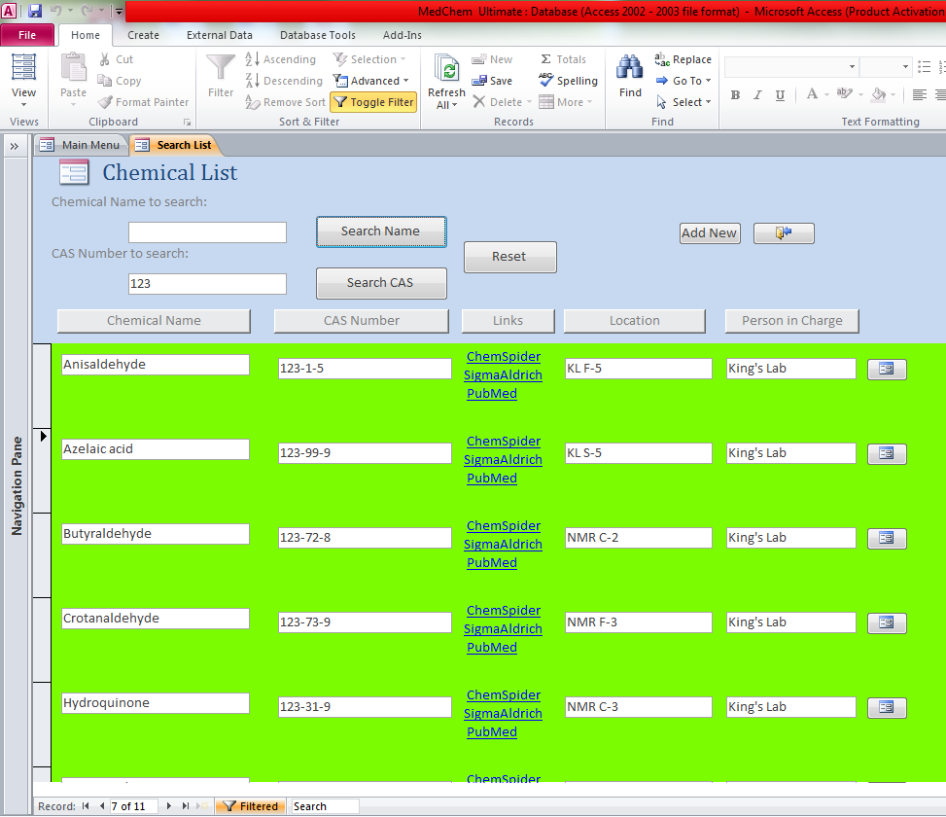
Figure 1. Chemical List main view
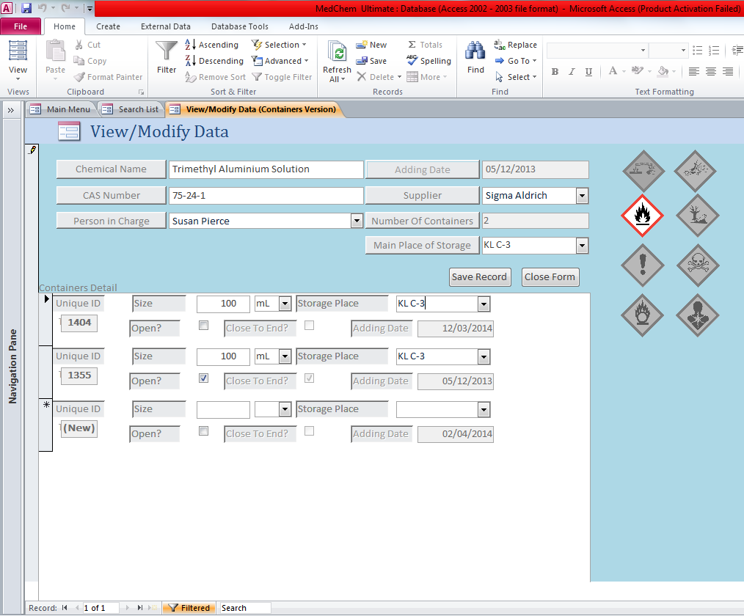
Figure 2. Model of a chemical entry in the database.

